Leader in Sustainability News Release Template
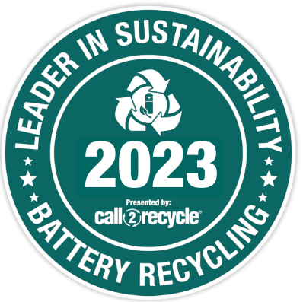
ORGANIZATION LOGO
[Organization] Recognized as a 2023 Leader in Sustainability

[Organization] is pleased to announce that it has been named by Call2Recycle Canada, Inc. as a 2023 Leader in Sustainability. The Leader in Sustainability Award is granted each year to organizations that display exceptional commitment to the environment and responsible battery management.

**OPTIONAL** [Your Organization] collected [quantity] kilograms of household batteries through the Call2Recycle® program in 2023, making it one of the program’s top-performing partners.

With this recognition, [Your Organization] joins a celebrated group of major retailers, waste recyclers, municipalities, and businesses, setting a high standard for waste diversion and environmental excellence.

“Each year, Canadians recycle more and more of their used batteries with Call2Recycle thanks to the ongoing partnership of organizations like [Your Organization]. This partnership speaks to a real commitment to sustainability and makes a significant difference,” said Joe Zenobio, President of Call2Recycle Canada, Inc. “The support we receive from “[Your Organization] helps us achieve our mission of maximizing battery diversion from the waste stream, which in turn protects wildlife, the environment and our communities.”

{Insert quote from your organization’s leadership about winning the award.}

###
{Add About [Your Organization]}
About Call2Recycle Canada, Inc.
Call2Recycle® is Canada’s leading organization for battery collection and recycling, fulfilling product stewardship obligations on behalf of over 400 members, including producers of single-use and rechargeable batteries. Call2Recycle powers Recycle Your Batteries, Canada!, its household and e-bike battery collection and recycling program. The organization operates provincially-approved programs in British Columbia, Saskatchewan, Manitoba, Quebec, and Prince Edward Island. It also functions as a registered Producer Responsibility Organization (PRO) in Ontario, adhering to the Ontario Batteries Regulation. It offers collection and recycling services for household batteries (weighing up to 5 kg), as well as e-transport batteries used to power e-bikes, e-scooters, e-skateboards, hoverboards, and Electric Vehicles (EVs).
Since its inception in 1997, Call2Recycle has diverted over 45 million kilograms of batteries from Canadian landfills. It upholds its commitment to operating the highest quality battery recycling program in Canada and holds certification in the most rigorous and globally respected standards, including R2v3, ISO 14001, ISO 45001, ISO 9001, as well as exclusively contracting with an ISO 27001 certified supplier for all IT infrastructure management. This reputation for excellence has enabled Call2Recycle to maintain trusted, long-term relationships with stakeholders and establish a network of more than 10,000 participating collection locations across Canada, including at leading retailers and municipal facilities.

For more information, please contact:
{Add Your Organization’s Contact Info for Media}

