Call2Recycle, Your Battery Collection and Recycling Program
© 2020 Copyright Call2Recycle Canada, Inc. All rights reserved.

As the Government of Ontario implements a new end-of-life Batteries Regulation and phases out Stewardship Ontario on July 1, 2020, Canada’s leading national consumer battery collection and recycling program, Call2Recycle®, can support you to start, continue and expand your municipal consumer battery collection program, without additional cost or interruptions in service.

Call2Recycle is the provincially-approved consumer battery collection and recycling program in the regulated provinces of British Columbia, Manitoba, Quebec and Prince Edward Island and collects voluntarily in all other provinces. Calll2Recycle has been leading battery collection and recycling in Canada for the last 22 years and since program inception, has collected and recycled more than 22 million kilograms of batteries.

Making the Change Easy! The Call2Recycle Advantage

Provincewide Reach
With 22 years of experience safely collecting and recycling single-use and rechargeable consumer batteries, Call2Recycle is committed to working with all municipalities, regardless of location, to facilitate a seamless transition to our program under the new Regulation.

Competitive Compensation
With the Call2Recycle program, compensation will be reviewed and re-established subject to the regulated categories as equal to or greater than current compensation for battery collections.

Simple Transition and Choice of Service Provider
Call2Recycle’s best-in-class program incorporates seamlessly into your existing municipal collection program which will remain unchanged except for the formal inclusion of rechargeable batteries, new contracts to sign (Ontario municipalities may continue to work with their existing service providers under the Call2Recycle program), and an easy-to-use Call2Recycle reporting portal.

No Disruption to your Current Service
Call2Recycle is fully compliant with all regulatory mandates and will ensure an easy transition from Stewardship Ontario. This means there will be no changes required for:
Curbside Collections: We welcome the curbside collection program and will continue to operate it if municipalities wish to proceed.
Depot Collections: Call2Recycle welcomes all depots, however, there is an option to run the collection program through municipal offices, community centres, libraries, etc., and through curbside or a combination of all the above. Collection locations are to be determined by the municipality.
Current Service Providers: Each municipality may determine which service provider you prefer to work with and inform Call2Recycle.

Dedicated Support
To support Ontario municipalities making the transition, Call2Recycle provides dedicated resources and customer service personnel.

Safest Program
Call2Recycle is the only Responsible Recycling, R2-Certified battery collection and recycling program in Canada, adhering to the highest recognized standards for battery collection, transportation and recycling safety. Our collection boxes include a flame-retardant liner for safe collection and transportation and Call2Recycle provides collection partners with site safety training and an information portal.
© 2020 Copyright Call2Recycle Canada, Inc. All rights reserved.

On the Ground & Ready to go in Ontario
+ Recognized for ensuring regulatory compliance, program safety, quality and responsiveness with program and operational transparency
+ Offers easy transition from Stewardship Ontario
+ Incorporates seamlessly into existing municipal collection program working with your existing service providers as preferred
+ Maintains or increases your recycling revenue
+ Expands your collection offerings to include rechargeable consumer batteries
+ Enjoys strong relationship with the Association of Municipalities of Ontario
+ Provides best-in-class customer service
+ R2 certified, prioritizes safe battery collection, transportation and recycling
+ Conducts public education and awareness campaigns encouraging battery recycling

Learn More!
Start, transition or continue your municipal consumer battery collection program with Call2Recycle by visiting www.call2recycle.ca/ontario-municipal-enrollment or by contacting the Call2Recycle team at 1-888-224-9764.

About Call2Recycle

22+ YEARS
experience managing collections
and regulatory compliance

WORKS WITH 300 MUNICIPALITIES
across Canada – 70 in Ontario

MORE THAN

22 Million kg
of used batteries collected
since program inception.

R2 Certified

STRONG TIES TO

AMO

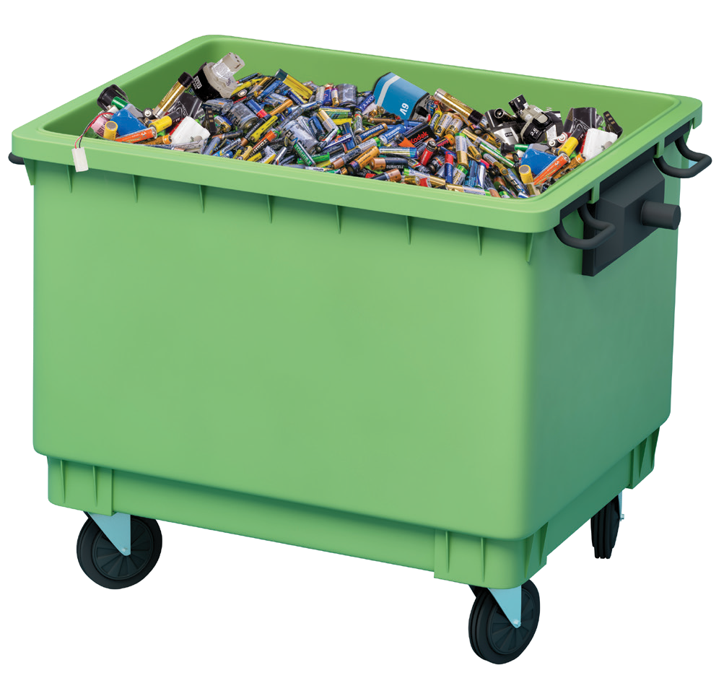Learn More

Start, transition, or continue your municipal collection program to Call2Recycle, by visiting call2recycle.ca/ontario-municipal-enrollment or
1-877-723-1297 • call2recycle.org
by contacting the Call2Recycle team at 1.888.224.9764

Michael MacDonald

Director Ontario, Call2Recycle mmacdonald@call2recycle.ca 647-484-2670

On the Ground & Ready to go in Ontario
+ Recognized for ensuring regulatory compliance, program safety, quality and responsiveness with program and operational transparency
+ Offers easy transition from Stewardship Ontario
+ Incorporates seamlessly into existing municipal collection program working with your existing service providers as preferred
+ Maintains or increases your recycling revenue
+ Expands your collection offerings to include rechargeable consumer batteries
+ Enjoys strong relationship with the Association of Municipalities of Ontario
+ Provides best-in-class customer service
+ R2 certified, prioritizes prioritizes safe battery collection, transportation and recycling
+ Conducts public education and awareness campaigns encouraging battery recycling

HOW THE PROGRAM WORKS
&

More than 300 companies fund the Call2Recycle® program through EHFs
or voluntarily

About Call2Recycle

22+ YEARS
experience managing collections
and regulatory compliance

WORKS WITH 300 MUNICIPALITIES
across Canada – 70 in Ontario

MORE THAN

22 Million kg
of used batteries collected
since program inception.

ESTABLISHED IN 1997

R2 Certified

STRONG TIES TO

AMO

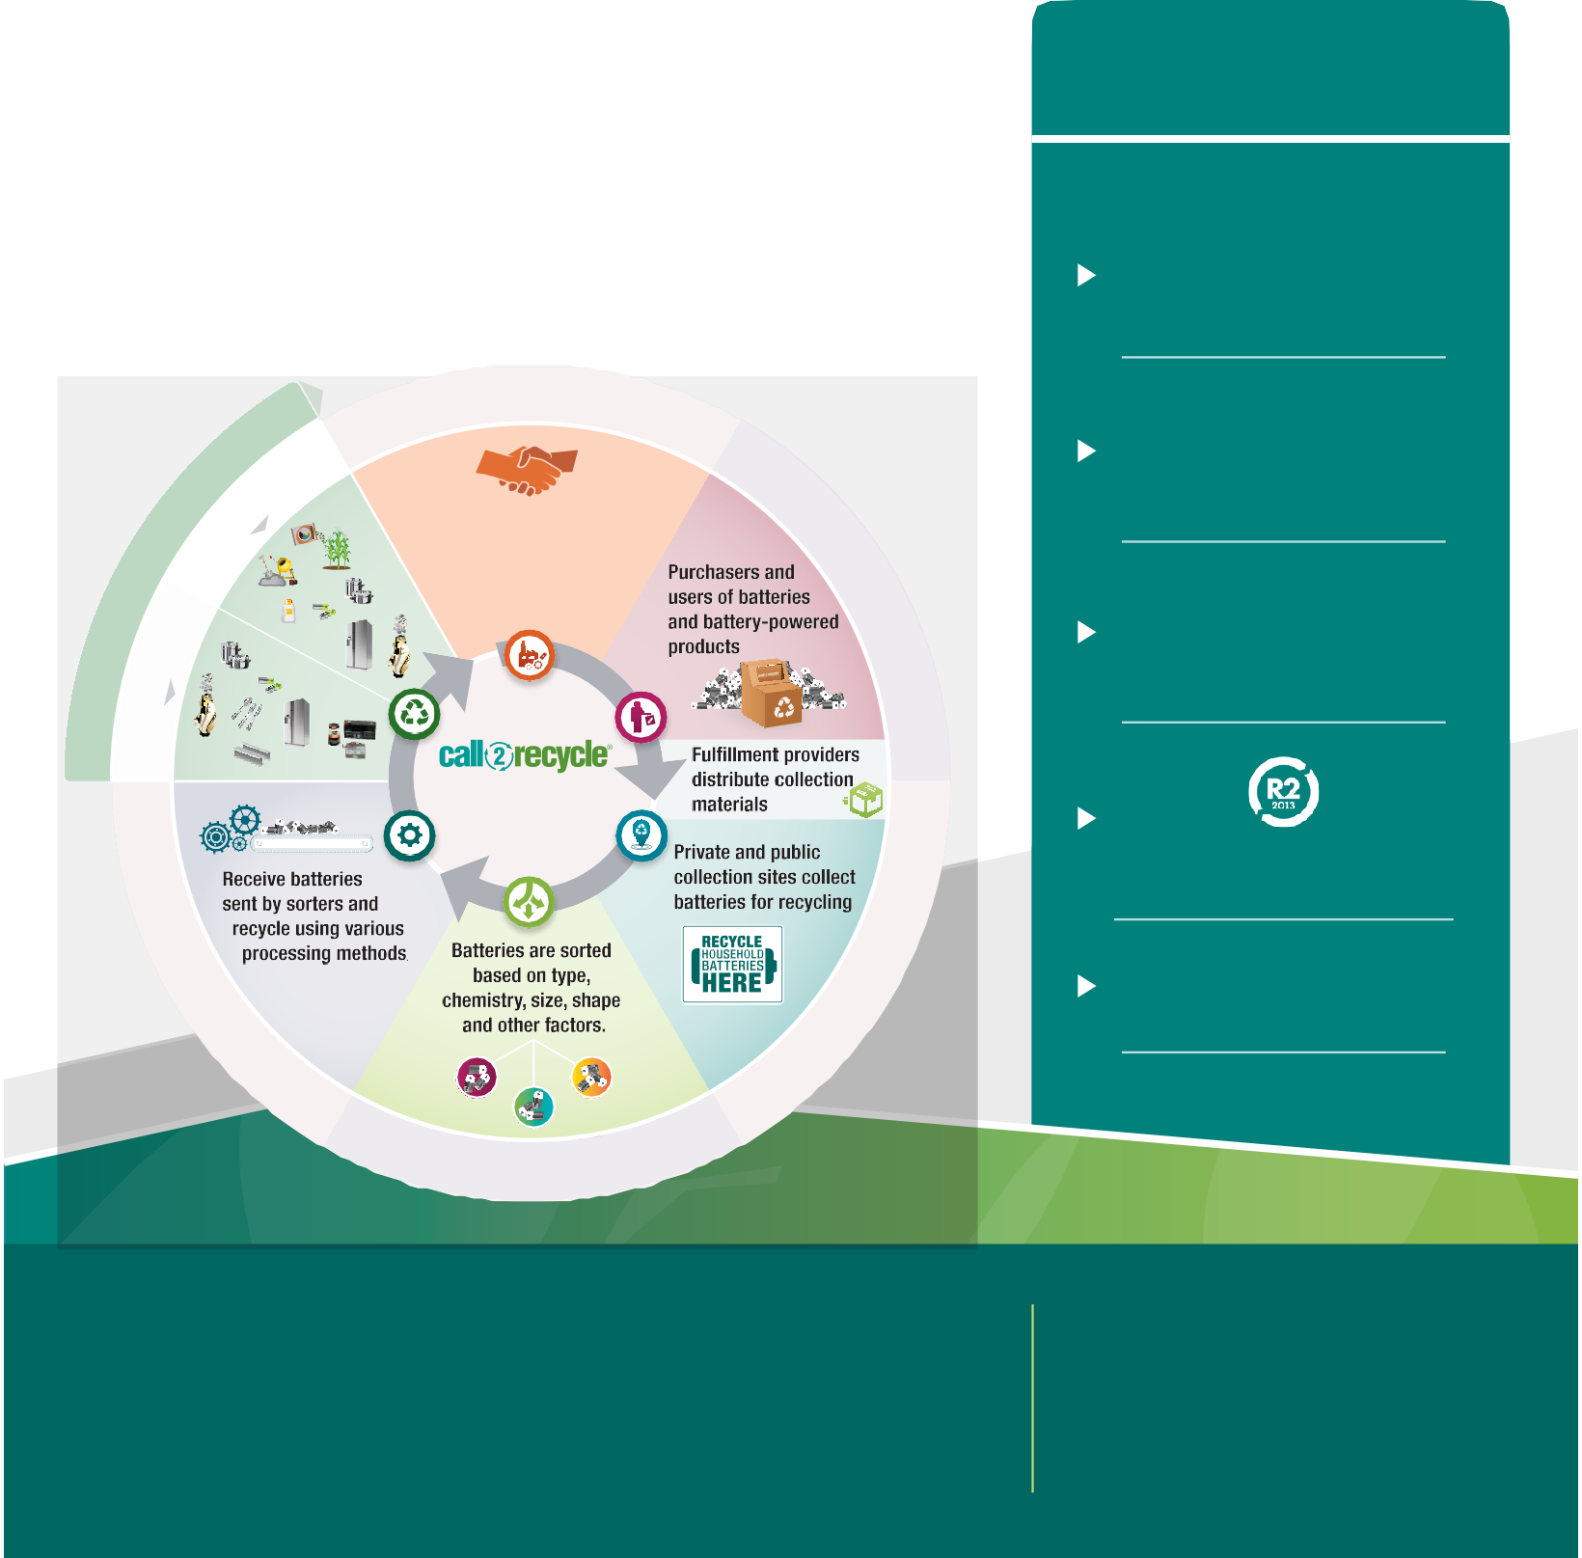
Learn More
Y

Start, transition, or continue your municipal collection program to Call2Recycle, by visiting call2recycle.ca/ontario-municipal-enrollment or
1-877-723-1297 • call2recycle.org
by contacting the Call2Recycle team at 1.888.224.9764

Michael MacDonald

Director Ontario, Call2Recycle mmacdonald@call2recycle.ca 647-484-2670

