Sample Battery Recycling Social Media Posts for Municipal Collection Partners

Sample Post 1:
Region of XYZ/Town of XYZ/City of XYZ is now accepting both single-use and rechargeable household batteries at our XYZ location/depot. Keep our community clean and green, by dropping off your old batteries today. Learn more here https://www.call2recycle.ca/recyclemybatteries/
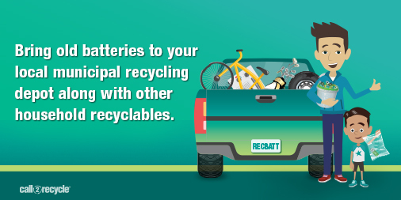

Sample Post 2:
Are batteries on your recycling list? They should be! Learn more about why, how, and where to recycle your batteries here: https://www.call2recycle.ca/recyclemybatteries
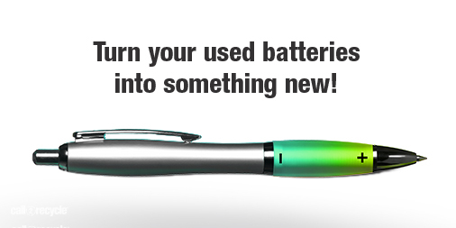

Sample Post 3:
Recycling your batteries helps protect your community and wildlife from materials that may harm the environment if they end up in landfills. Collect your old batteries and recycle them at your local municipal location today! Learn more here https://www.call2recycle.ca/recyclemybatteries/

Sample Post 4:
Responsible battery recycling practices ensure batteries are handled in a way that reduces potential fire hazards. Never throw your old batteries in the garbage. Before handling old batteries, take a look at these safety tips: https://www.call2recycle.ca/recyclemybatteries

Sample Post 6:
Battery recycling helps ensure no battery goes to waste! Materials reclaimed from recycled batteries can be used to make new products such as batteries, bicycles, stainless steel water bottles, and golf clubs. Take a look here for more on the battery recycling journey.
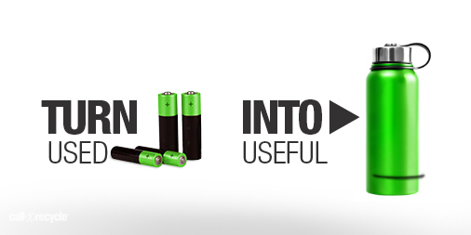

Sample Post 7:
When you recycle your batteries, you’re doing your part to help create a cleaner and greener environment for our children and a more sustainable planet. Drop-off your used household batteries at your local municipal location today! Learn more here: https://www.call2recycle.ca/recyclemybatteries/
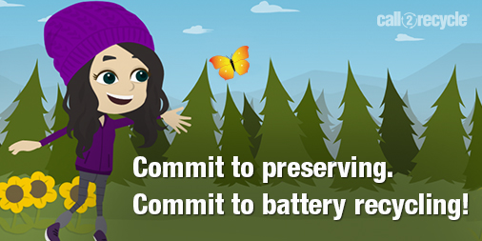

Sample Post 8:
Why recycle your batteries? To help reduce pollution and contribute to a more sustainable environment. Keep our community clean and green, by visiting your local municipal recycling location to recycle your old batteries: https://www.call2recycle.ca/locator/

