Leader in Sustainability News Release Template
ORGANIZATION LOGO 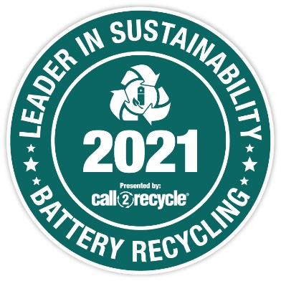
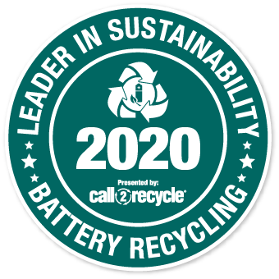
[Your Organization] Recognized as a 2021 Leader in Sustainability
[City, Province, Date], 2022 - [Your Organization] has been named by Call2Recycle Canada, Inc. as a 2021 Leader in Sustainability. The Leader in Sustainability Award is granted each year to organizations that display exceptional commitment to battery recycling. [Your Organization] collected [quantity] kilograms of household batteries through the Call2Recycle® program during 2021, making it one of the program’s top-performing partners.
{This is the [#] time [Your Organization] has received Call2Recycle®’s Leader in Sustainability Award. It was also recognized for its outstanding performance in [X year], making it part of a celebrated group of major retailers, waste recyclers, municipalities, and businesses setting a standard for organizational leadership in this area.}
OR
{This is the first time [Your Organization] has received Call2Recycle®’s Leader in Sustainability Award. With this recognition, [Your Organization] joins a celebrated group of major retailers, waste recyclers, municipalities, and businesses, setting a standard for organizational leadership in this area.}

“Each year, Canadians recycle more and more of their used batteries with Call2Recycle thanks to the exceptional partnership of organizations like [Your Organization]. Its commitment to sustainability and diverting batteries from the waste stream for reuse in new products is making a real difference,” said Joe Zenobio, President of Call2Recycle Canada, Inc. “With [Your Organization]’s support, we have been able to achieve record collection targets year after year, helping to protect wildlife, the environment and our communities by keeping toxic metals out of landfill.”
{Insert quote from your organization’s leadership about winning the award.}

###

{Add About [Your Organization]}

About Call2Recycle Canada
Call2Recycle® is the provincially-approved consumer battery collection and recycling program for British Columbia, Saskatchewan, Manitoba, Quebec, and Prince Edward Island, and operates as a registered Producer Responsibility Organization (PRO) in Ontario according to the Ontario Batteries Regulation. Call2Recycle accepts household batteries (weighing up to 5 kg) for recycling and eMobility batteries used to power eBikes, eScooters, eHoverboards and eSkateboards.
Since its inception in 1997, Call2Recycle has diverted over 33 million kilograms of batteries from Canadian landfills and meets or exceeds the most rigorous recycling standards for safe battery recycling and management. Working on behalf of its stakeholders and with a network of more than 9000 participating collection locations across Canada, Call2Recycle Canada continues its pursuit of ensuring responsible battery recycling is accessible for all. Learn more at call2recycle.ca or call 1.888.224.9764.
For more information, please contact
{Add Your Organization’s Contact Info for Media}

